CITY PARK REFORESTATION PLAN

2018
City of Bandon
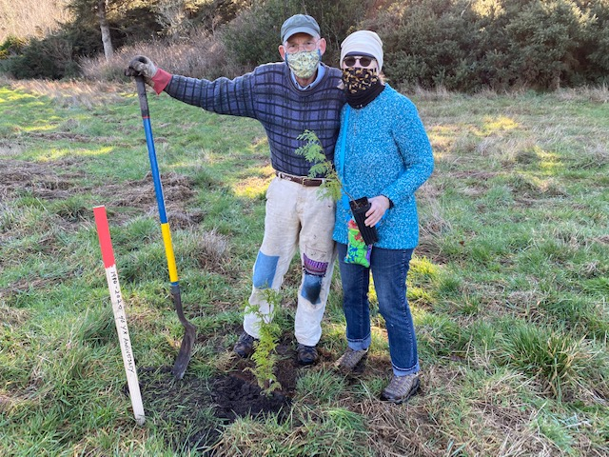
December 1, 2021

City of Bandon
Parks & Recreation Commission

Acknowledgements

City Staff
Dana Nichols, Planning Manager
Tim Lakey, Public Works Supervisor

City of Bandon Parks & Recreation Commission
Christine Hall, Chair
Steve Friedland
Samantha Stanger
Laurea Arnoldt
Shannon Hartlep
Nicolette Cline

Project Consultant
Darcy Grahek, Stillwater Natives Nursery

The Role of Urban Forests

Why did we create this plan and how do we intend to use it?

Trees play an important role in our urban ecosystem, providing shade, clean air, storm drainage mitigation, and animal habitat. In our City Park, trees enhance the outdoor recreation experience and create a pleasant and enjoyable environment for all citizens.

We recognize that our park system is integral to Bandon’s urban form and want to ensure that our forests remain safe, healthy, and diverse for years to come. As trees are lost to storms, disease, and drought, we want to ensure that they are replaced with varieties that will work in tandem with the existing ecosystem and thrive in our unique coastal climate.

“Trees are poems the earth writes upon the sky.”
- Kahlil Gibran
The City Park Reforestation Plan was created to provide a road map for managing, maintaining, and replanting trees in City Park. This document lays out a vision for the future of City Park, recognizing our financial, geographic, and environmental constraints. We have selected trees that are native to this region and that require low maintenance, upon both planting and in the long-term.

In this document you will find history of City Park, information about our growing climate and environmental constraints, a roadmap for reforestation, budget and timeframe, and maintenance plan. This Plan is intended to be a living document and will be updated as needed by the City of Bandon Parks & Recreation Commission.

Historical Background

The City of Bandon was incorporated in 1891. Shortly thereafter, the City made a commitment to park system development, by passing Ordinance Number 203 in 1912 requesting voter approval for authorization to purchase 15 acres of land for the sum of $6,000. The citizens of Bandon approved the acquisition to create a public park. Since the original creation of City Park, we have continuously strived to enhance and improve park amenities to reflect the community's needs.

In recent years, City Park has weathered storms that have significantly affected the number of healthy trees in the park. Some trees have been lost to disease and wind damage, while others have simply reached the end of their normal lifespans. The City’s Public Works Department estimates that nearly 25% of the trees have been lost in the last five years alone.

Recognizing the visible impact that the loss of trees has on both the aesthetic and functional nature of the space, the Parks & Recreation Commission pursued development of a Reforestation Plan to ensure that when trees come down, there’s a plan in place to replant, rebuild, and regrow our tree canopy. In place of what was mostly shore pines, the Commission has opted to envision a future park that has a variety of native and non-invasive species of trees, shrubs, and plants that will create a vibrant, healthy ecosystem and bring back diversity.

Site Analysis

[Needs to be completed by a professional]

Tree Inventory
[To be completed using the online Oregon Forestry Program tool]

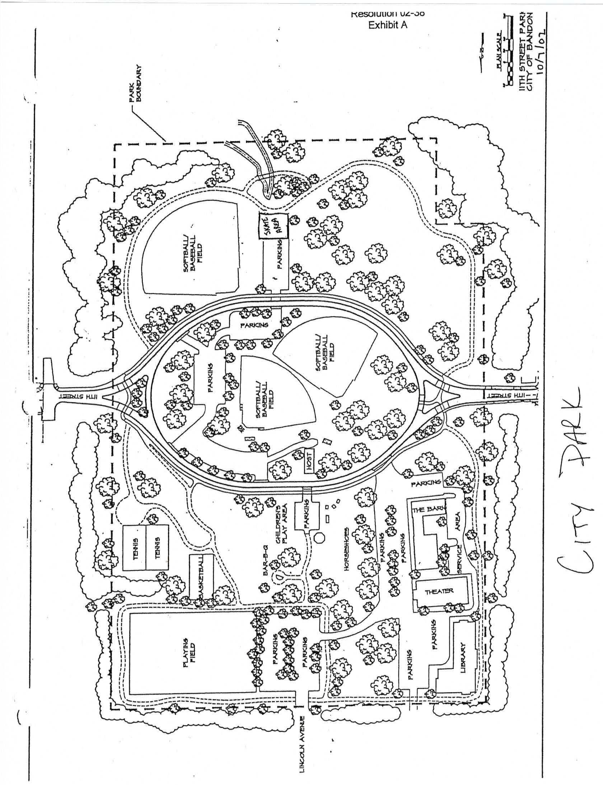
Replanting Plan
Figure 1 Priority Area map for replanting

Commissioners, in partnership with local native plant specialist Darcy Grahek, identified and received over 500 trees from the Bureau of Land Management. Over a period of five years, the City intends to plant some of these trees in the park in groupings with other shrubs to create pockets of plantings that provide shade, wind protection, and visual appeal, but that will not get in the way of other activities already happening in City Park, such as disc golf, softball, and walking.

A map of the City Park is provided above. The areas circled in blue are priority areas for replanting in the five-year horizon for this plan. We know that plantings in the fall tend to be more successful than those in the spring because the seedlings and saplings need water to thrive, and without irrigation we rely on our wet winter months to naturally nurture our trees.

The five priority areas are: (1) the area behind the playground and on the berm of the amphitheater, (2) the inner loop of the park on the outskirts of the ball fields, (3) the wooded area on the south side of west entrance, (4) the south side of the east entrance to the park, and (5) the north side of the east entrance to the park.

Each priority area serves a different purpose and will have different actions and planting suggestions. While each priority area has different problems to solve, there are general objectives we are working towards throughout the park. These include:

- Baffle/buffer wind
- Improve visual appearance
- Plan for low maintenance, climate adapted
- Remove barriers for play
- Increase diversity

Priority Areas
To meet these objectives, we have developed actions for each area, and associated recommended plantings. These are listed below in greater detail.

Priority Area #1: Playground and Amphitheater (Fall 2021)
Actions:
- Remove dead and damaged shore pines
- Cover stumps and surround trees with native berries to encourage natural, low-maintenance decay
- Create a wind break at the basketball/pickleball courts
- Create a wind break and visual improvement surrounding amphitheater
- Plant trees that can withstand wind, and mostly dry land

Plantings:
- Spruce trees along northern perimeter of basketball/pickleball court
- Spruce and pine around perimeter of amphitheater
- Red Cedars in swales
- Flowering shrubs such as ceanothus, red flowering currant, and berries
- Sala, twin berry, and huckleberry to cover stumps and surround trees
- Place driftwood logs and low-lying plantings along parking lot perimeter above amphitheater
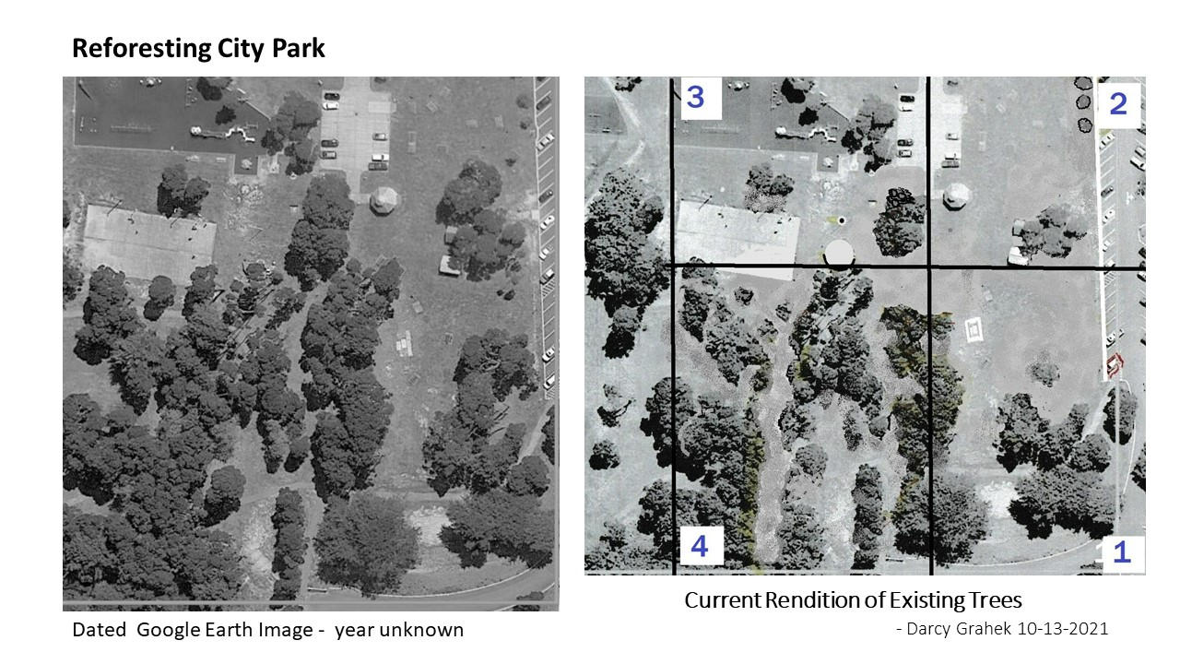
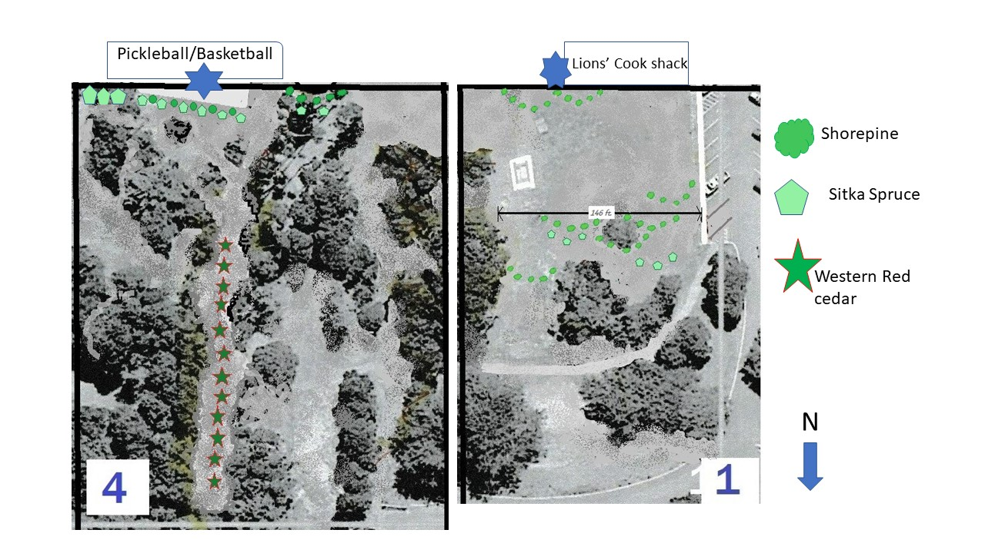
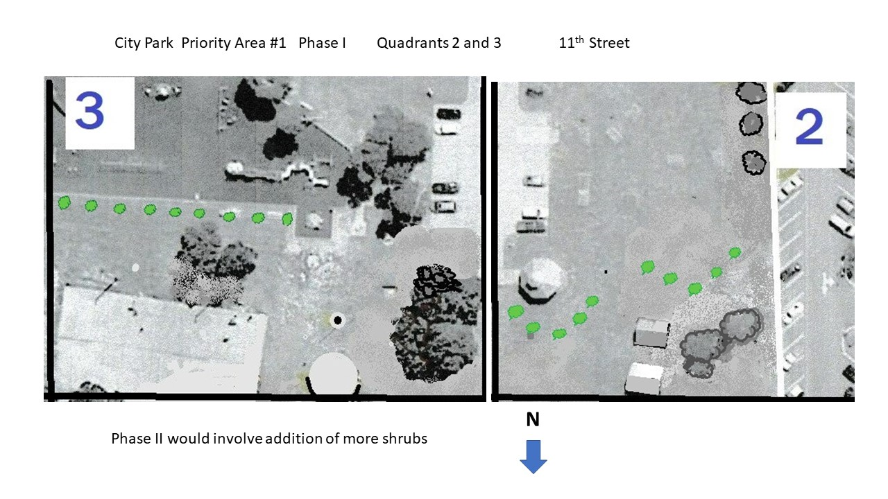

Priority Area #2: Inner loop (Fall 2022)
Actions:
- Remove dead and damaged shore pines
- Cover stumps and surround trees with native berries to encourage natural, low-maintenance decay
- Keep sight lines open, while creating some wind protection
- Increase diversity: pines, firs, and low-lying companion plants
- Create visual appeal, use of ornamentals acceptable here

Priority Area #3: Disc Golf and Walking paths (Fall 2023)
Actions:
- Remove dead and damaged shore pines, thin trees out for healthier environment
- Cover stumps and surround trees with native berries to encourage natural, low-maintenance decay
- Increase diversity: Plant trees and plants that can tolerate more moisture and shade
- Keep visual sight lines open for disc golf course

Priority Area #4: East Entrance, South (Fall 2024)
Actions:
- Remove dead and damaged shore pines
- Cover stumps and surround trees with native berries to encourage natural, low-maintenance decay
- Thin out trees and ensure safety and sight-lines from street
- Create visual appeal, use of ornamentals acceptable here

Priority Area #5: East Entrance, North (Fall 2025)
Actions:
- Remove dead and damaged shore pines
- Cover stumps with native berries to encourage natural, low-maintenance decay
- Protect surrounding properties with more border trees
- Increase diversity: plant trees sun-loving trees that can withstand wind and low moisture

Tree Species and Groupings

Donated trees include Douglas Fir, Western Hemlock, White Fir, Pacific Crabapple, Big Leaf Maple, Engelman Spruce, Shore Pine, Ponderosa Pine, Western Red Cedar, Port Orford Cedar, and Red Alder. Companion plants include huckleberry, salal, twin berry, wax myrtles, Oregon grape, silk tassel, flowering red currant, ceanothus, and salmonberry.

Groupings of plants may look like the following:

[insert artistic sketch of planting]

Tree Type | Scientific Name | Description
CONIFERS - Needle-like or scale-like mostly evergreens that produce cones
DOUGLAS FIR | Pseudotsuga menziesii | - Lumber high-demand due to strength of wood fibers  - Easily injured by high winds (needs protection in numbers/variety)  - Climax species  - Needs protection from wind and salt spray via Sitka Spruce, Shore Pine, Western Red Cedar to thrive.
PORT-ORFORD CEDARS | Chamaecyparis Lawsoniana | - Native to Coos County  - Also known as White or Oregon Cedar (Lawson Cypress)  - Resistant to fires  - Phytophthora lateralis is a soil-borne plant pathogen that has wiped out high  - high rate of cedars forests since the mid-1950s.  - Stewardship of this native species is only way to ensure survival  - Keep out of areas that spend significant amounts of time underwater due to rot
SITKA SPRUCE | Picea Sitchensis | - Lives over 700 years  - Susceptible to fires  - Grows quickly (4.9ft per year)  - Shallow roots that run long and lateral underneath ground  - Stewardship necessary to allow species to thrive  - Strong and sturdy. Forefront tree for wind along with shore pine.  - At present there are only two insects of economic significance attacking Sitka spruce; the large Pine Weevil (Hylobius abietis L) and the Green Spruce Aphid (Elatobium abietinum Walker). The large Pine Weevil is a familiar insect to most foresters. Common beetles and wasps are predators.  - Also needs to be in area not undulated with water.
WESTERN HEMLOCK | Tsuga Heterophylla | - Lives over 1200 years  - Helps reduce erosion  - Shade tolerant and does well in areas with standing water. Does not do well in drought or dry zones. Shallow roots searching for nutrients, needs to be planted in stands of trees that create large and diverse humus layer every year.  - CLIMAX SPECIES- (vs PIONEER species)  - grows with limited resources (heat and water)  good competitor, poor colonizer  - highly adapted to predictable environments  - Douglas-fir is a climax species as well
WESTERN RED CEDAR | Thuja Plicata | - Part of Cupressaceae family (not true cedars, just like PO Cedar)  - Associated heavily in forests with Douglas-Fir and Western Hemlock  - Not to be planted in large hoards with other cedars, susceptible to many cedar root  - Diseases. Needs wind break, shade tolerant.
SHORE PINE | Pinus contorta | - Dominates the city park landscape thus far. Need to be replanted to ensure the next generation.  - Plant in groves with Sitka spruce, Western red cedar, Douglas fir, and understory shrubs.  - Highly adaptable and can withstand high winds and bogs.  - Tolerant of salt spray and low-nutrient conditions.
WHITE FIR | Abies grandis | - Common on the coast but not as close as City Park. When it is, accompanied by Ponderosa Pine and Douglas Fir.  - Spodosol soils: acid soils with humus layer consisting of Aluminum and Iron  - Does not do well in high winds, needs a wind block until well established.  - Does well in valleys or stream bottoms with high-water levels.
SHRUBS/UNDERSTORY
EVERGREEN HUCKLEBERRY | Vaccinium ovatum | - Native oregon understory shrub  - Can grow to 10ft. Tall in the shade  - Loves acidic soil of the coast  - Small pink flowers in spring, small red berries in summer, matures to black in fall  - Bees/birds/butterflies LOVE  - High appeal and low maintenance, slow growing.  - Crucial to understory health in conifer forests  - Can live in shade or full sun. Needs to be incorporated throughout city park, crucial pollinator and prevents erosion.  - Does well on edges of forests or in openings.
RHODODENDRONS | Rhododendron macrophyllum | - Unlike many blooming plants, rhododendron does not like full morning sun in winter and does best when planted in dappled shade on the north side of a building. Growing rhododendrons are happiest in a location protected from the wind and not under eves of a building.  - Five Varieties native to PNW  - Adds color and density to understory  - Good for pollinators and protection  - Grows in fairly dry areas, dappled light or shade necessary.
RED ALDER | Alnus Rubra | - Associated in forests/streambanks with Douglas fir, western red-cedar, western hemlock and (deciduous) willow, red osier dogwood, Oregon ash, and bigleaf maple  - Host of a nitrogen fixing bacteria, actinomycete Frankia, on nodules of roots.  This is like the rhizome bacteria on legumes plant roots of the Fabaceae family, but regulates nitrogen in the soil rather than massive additions.  - PIONEER SPECIES-  - logged areas very susceptible to large infestations  - requires open area to be prolific  - poor competitor, excellent colonizer  - Prefers to live amongst water edges, riverbanks, wetlands, etc.
PACIFIC CRABAPPLE | Malus Fusca | - Medium height (36ft)  - Leaves irregularly lobed  - Fragrant white/pink apple blossoms  - Older red/brown bark heavily fissured  - Prefers wetlands, riverbanks  - “Deer Candy”  - Brings pollinators of all sorts and provides excellent cover  - Indigenous natives ate the tart fruit right off the tree or would store until soft and sweet in the fall. This species has a longstanding history with the Oregon Coast and the native Population.

Funding and Timeframe

The City anticipates replating City Park over a five-year period. Due to the dry summers and intense north wind, the Commission will plant trees in the fall months to achieve the greatest success. Replanting will involve: (1) removal of existing dead or unhealthy trees, (2) site preparation, (3) planting, (4) minimal on-going maintenance and reporting.

Year | Priority area(s) | Species and # | Cost
2021 | #1 |  | Stakes:
2022 | #2 |  | Stakes:
2023 |  |  | Stakes:
2024 |  |  | Stakes:
2025 |  |  | Stakes:

On-going Maintenance/Management
- Thin trees as they grow (begin at five years from planting)
- Replace trees that died annually – assess cause of failure
- Walk the park each spring with Commissioners, Staff, and professionals to determine if changes need to be made to Reforestation Plan

